WEEK -7
LOB LOGBOOK
NAME - LIKHITHA MAHADEVA

SID NUMBER - 2458682

ASSIGNMENT - WEEK 7

1.Graphs for Accuracy and Loss Function for VGG16 and VGG19 (4 graphs in total).
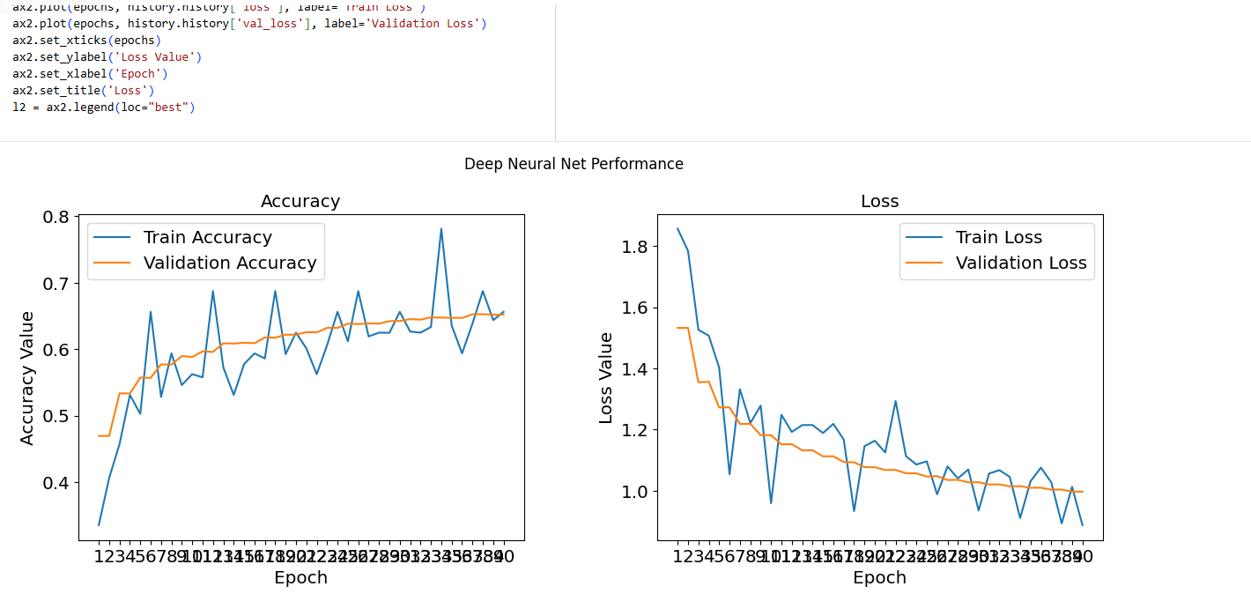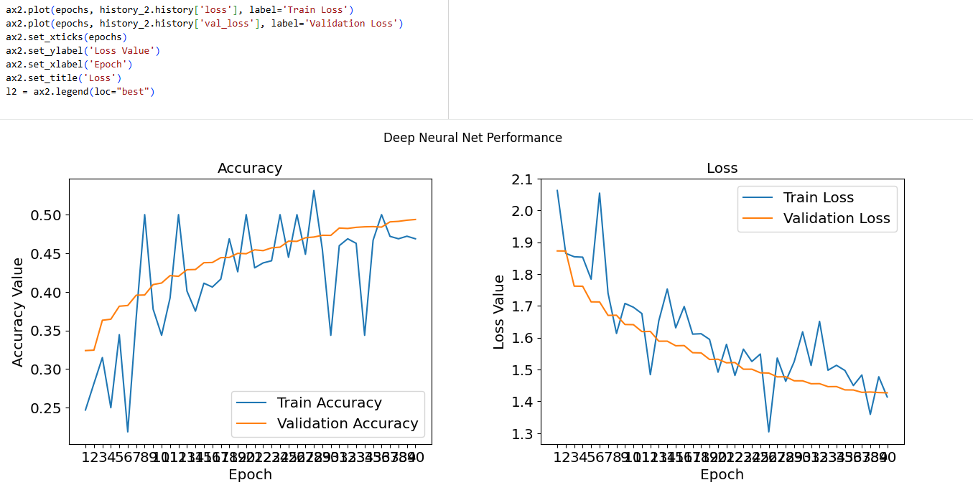

the optimal number of epochs for training your VGG16 and VGG19 models.

early-stop code
from tensorflow.keras.callbacks import EarlyStopping
LAST_DIGIT_IN_YOUR_SID = 12

early_stop = EarlyStopping(monitor='val_loss',patience=LAST_DIGIT_IN_YOUR_SID)

Add the final Performance Table
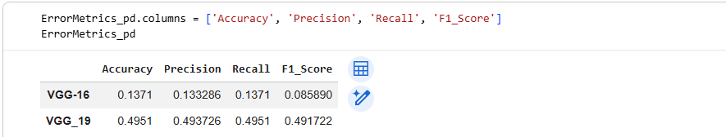

Plot the performance comparing histogram of VGG16 and VGG19
